**VB.NET Assignment 2**

**Monsuru Muadh Adekunle**

**FUO/22/0353**

**Question 1:**

| Imports System Module Program  Sub Main(args As String())  Console.WriteLine("How many lines:")  Dim counter As Integer = Int(Console.ReadLine())  For i As Integer = 0 To counter Step 1  Dim lines As String = New String("*", counter - i)  Console.WriteLine(lines)  Next  End Sub End Module |
| --- |

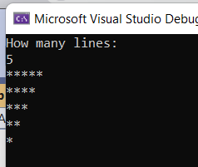

**Question 2:**

| Imports System Module Program  Sub Main(args As String())  Console.WriteLine("How many lines:")  Dim counter As Integer = Int(Console.ReadLine())  Dim begin As String = ""  Console.WriteLine("")  For i As Integer = 1 To counter Step 1  Dim lines As String = New String("*", counter - i)  Dim extra As String = "**"  begin += $"{i}"  Console.WriteLine($"{begin}{lines}{extra}")  Next  End Sub End Module |
| --- |

